**Screen Shots:**

**E-commerce website Sporty Shoes by Bhuwan Agrawal, Student at Simplilearn FSD course**

**Git repo: https://github.com/Desicoders/Sporty-Shoes-Ecommerce-website**

* **Usage:**
  + **Admin**

**Admin can do all the work of admin controller, products controller , and order controller like adding a new product, deleting a new product, viewing users, viewing orders sorted according to some category(like order id, order Date) and other features.**

* + **User:**

**User can do all the work of user controller like ordering some product, changing user’s password, see your own orders etc.**

* + **Unauthorised User:**

**Can see all the products and search in products.**

/api-docs

**Now from next page Swagger Api’s view has been generated. You can see the swagger api using the given below link after running the spring boot app Or you can use postman whose screenshots will also be attached with this file after swaggers view is over.**

**Swagger link:**

**http://localhost:1234/swagger-ui/index.html**

**Servers**

**http://localhost:1234 - Generated server url**

**user-controller*( user can use )***

**GET**

**GET**

**/users**

**/signout**

**GET**

**GET**

**/users**

**/order**

**/all**

**GET**

**GET**

**/users**

**/**

**PATCH**

**PATCH**

**/users**

**/update**

**/password**

**PATCH**

**PATCH**

**/users**

**/update**

**/name**

**POST**

**POST**

**/users**

**/signup**

**POST**

**POST**

**/users**

**/**

**signin**

**POST**

**POST**

**/users**

**/product**

**/{productid}**

**/order**

**products-controller**

**DELETE**

**DELETE**

**/products**

**/{productid}**

**/delete**

**GET**

**GET**

**/products**

**/{id}**

**GET**

**GET**

**/products**

**/searchByName**

**GET**

**GET**

**/products**

**/all**

**GET**

**GET**

**/products**

**/allGroupedByCategories**

**PATCH**

**PATCH**

**/products**

**/{productid}**

**/update**

**/{fieldname}**

**POST**

**POST**

**/products**

**/add**

**admin-controller (*admin can use*)**

**GET**

**GET**

**/admins**

**/users**

**/search**

**GET**

**GET**

**/admins**

**/users**

**/all**

**GET**

**GET**

**/admins**

**/signout**

**PATCH**

**PATCH**

**/admins**

**/{adminid}**

**/update**

**/password**

**POST**

**POST**

**/admins**

**/**

**signin**

**order-controller (*user can use)***

**GET**

**GET**

**/orders**

**/{productsid}**

**/order**

**/all**

**GET**

**GET**

**/orders**

**/all**

**/sorted**

**Postman Screen Shots:**

**Before running some information:**

* **Admin id (int)=** 10007

**Password(String)=**10007

* **User id(int)=** 10002

**Password(String)=** 10002

**Note: You can change these through data.sql file present in resources folder.**

1. **Unauthorised User Roles ScreenSots:**

* <http://localhost:1234/products/all>

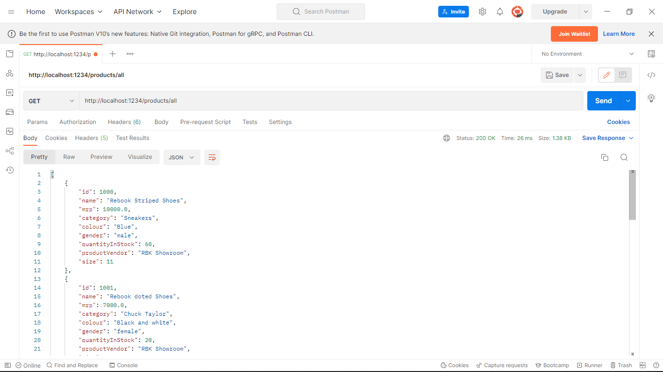

Can view All the products

* http://localhost:1234/products/searchByName?name=Addidas

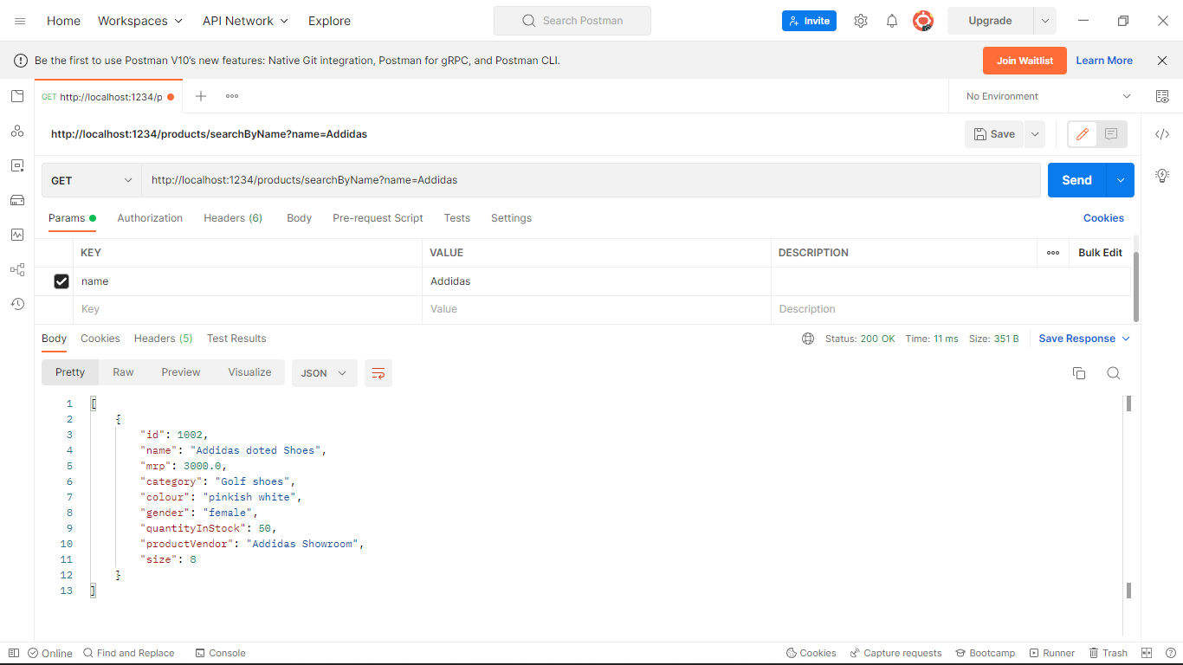

**Can search product by name**

* <http://localhost:1234/products/allGroupedByCategories>

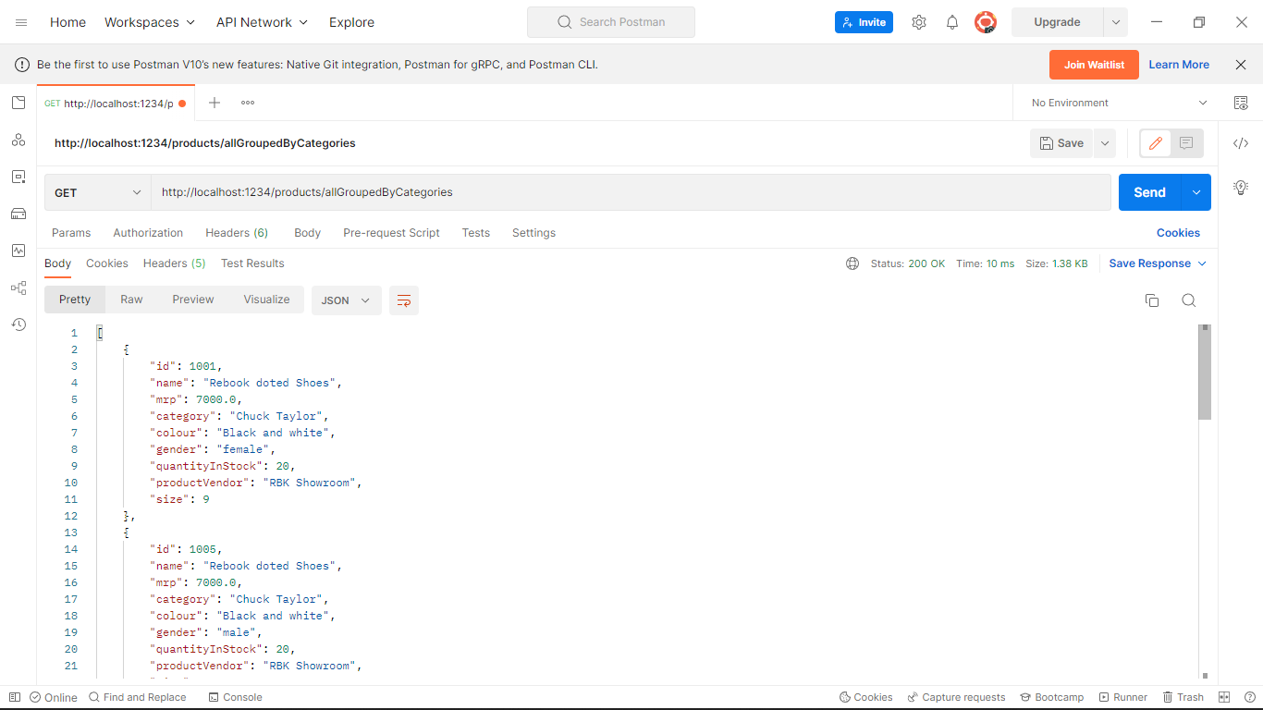

**Search Products based on categories.**

* <http://localhost:1234/users/signup>

example raw body input in user as json object:

{

     "name": "string",

     "password": "string"

}

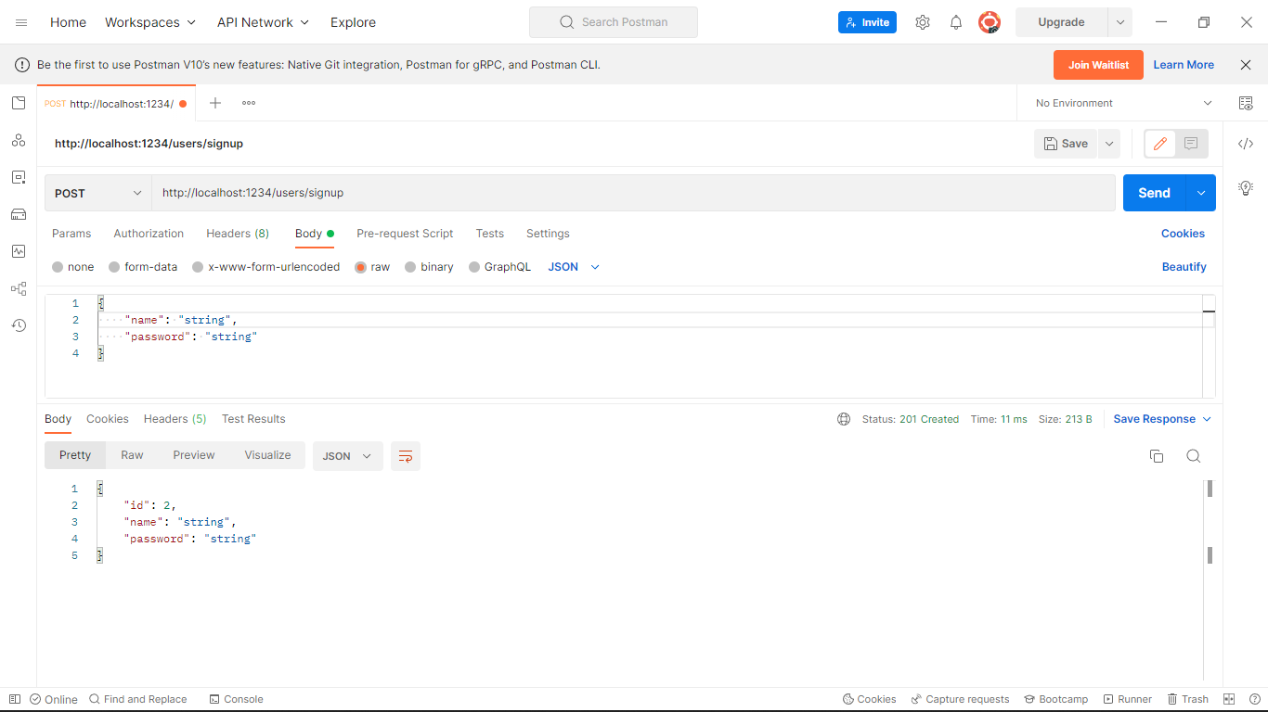

**Can create a use account.**

1. **User Roles:**

* <http://localhost:1234/users/>

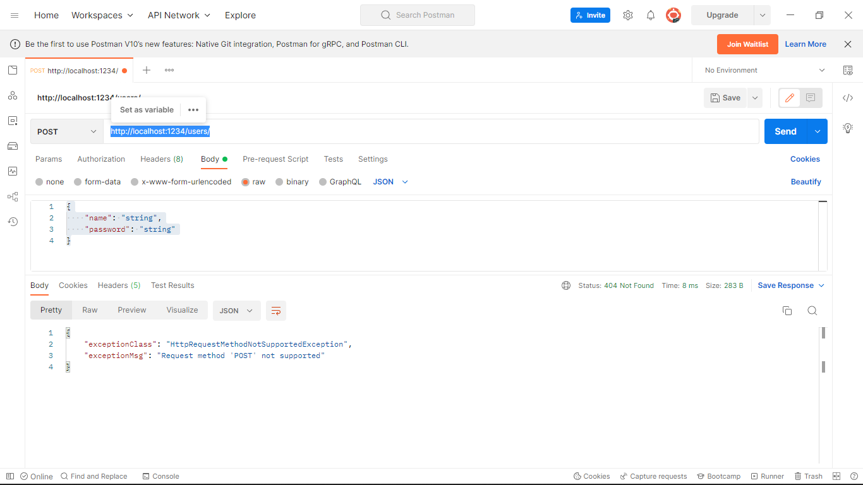

**Will get error if un authorized user tries to access user resources**

* <http://localhost:1234/users/signin>
* example raw body input in user as json object:
* {
* "id": 10002,
* "password": "10002"
* }

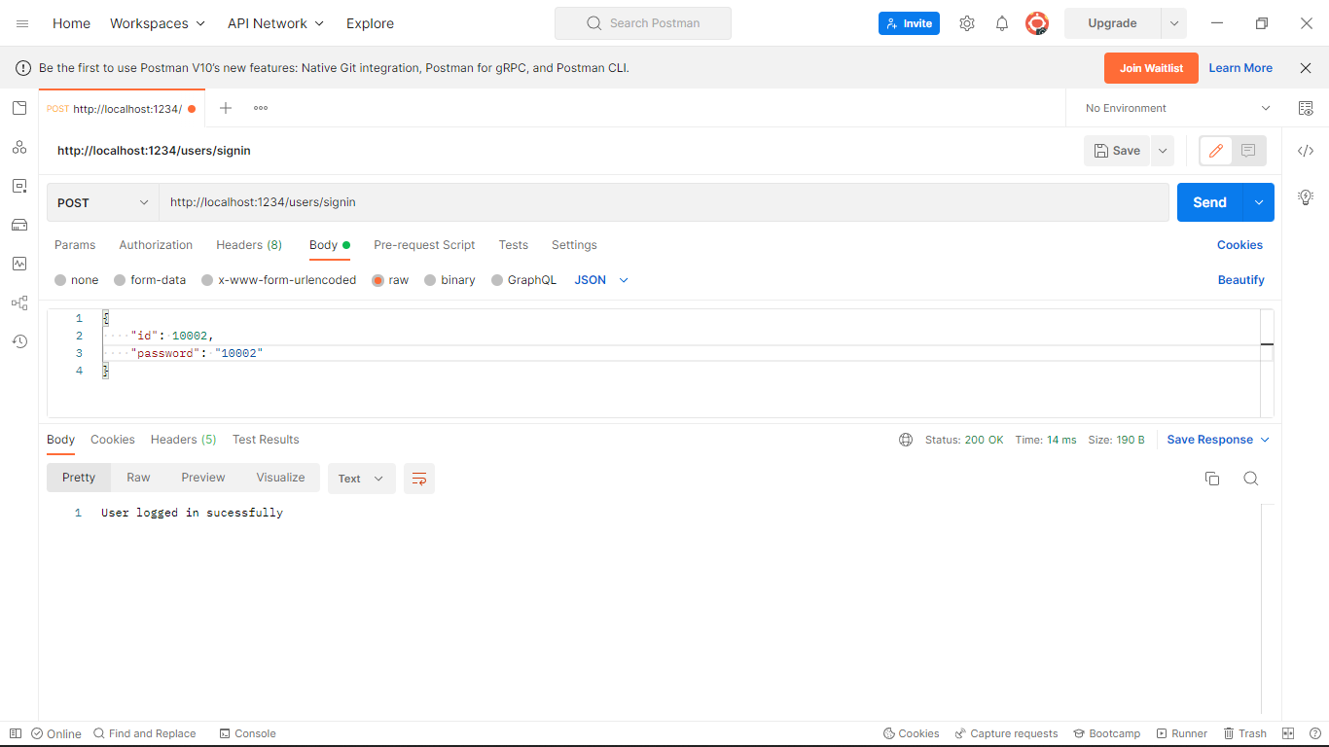

* **After logging in as User**
* <http://localhost:1234/users/>

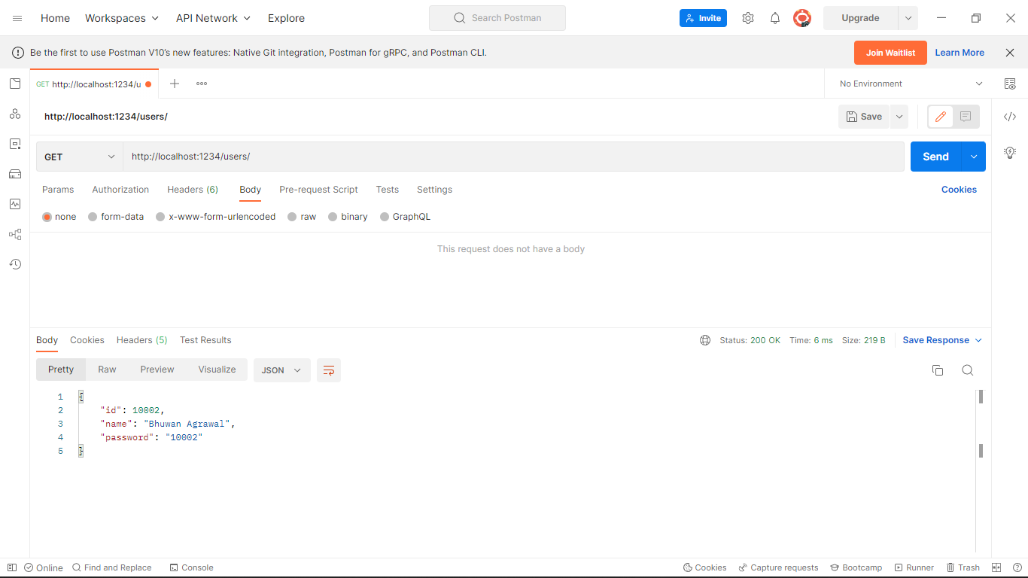

**Print user details**

**Similarly user can do all these things:**

**Screenshot taken from swagger-ui.**

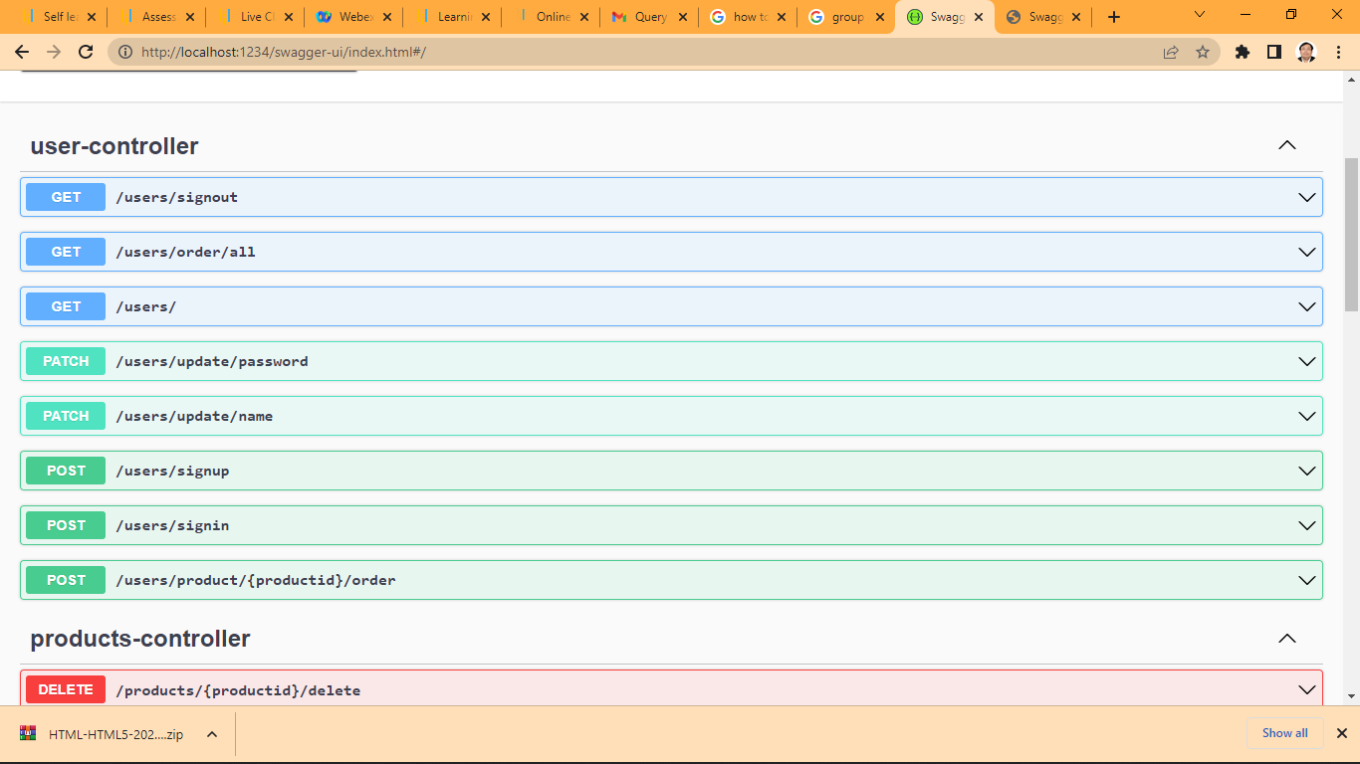

**Admin can do all these:**



